Areesha Raheel
55039
cybersecurity

Assignment 3: Enumeration and Access Testing
This assignment includes tasks related to brute-force attacks, directory enumeration, and authentication testing.

Gobuster
Gobuster is a directory/file enumeration tool written in Go, known for its performance and support for multiple scan types.
Example Command:
bash
CopyEdit
gobuster dir -u your site link-w /usr/share/wordlists/dirb/common.txt

Gobuster
Objective: To discover hidden directories and files.
Method: Directory brute-forcing.
Result: Several unlisted directories were found.
Security Impact: Hidden directories may expose sensitive files if not secured.
Risk Level: Medium

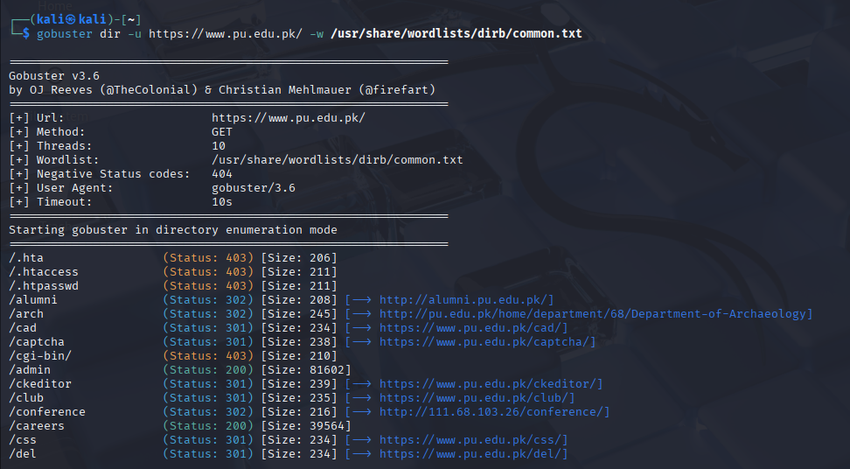

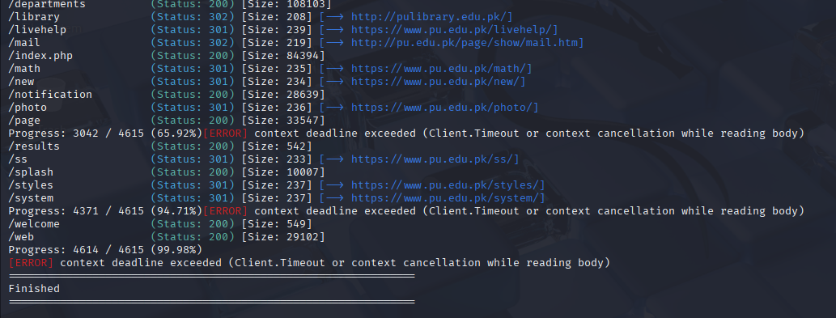

Hydra
Hydra is a fast and flexible login cracker that supports numerous protocols and is commonly used for brute-forcing web forms and services.
Example Command:
hydra -L users.txt -P passwords.txt your link http-get




